**Applied Data Science 1**

**Assignment – 2 (Statistics and Trends)**

Name: - Hetanshi Kachhiya Patel

My repo file link: - https://github.com/hetanshipatel/Trends-and-Statistics-ADS-assignment-2

**Climate change data analysis based on World Bank data**

To analyse the change in Life expectancy, Death rate, Urban Population and Fertility Rate in different 8 countries from the different continents in the year 1960 to 2020. The below given record illustrates the relation of how much Life Expectancy and Death Rate changed in years from 1969 to 2019. Whereas the other two graph depicts the Urban Population and Fertility Rate from year 1960 to 2020

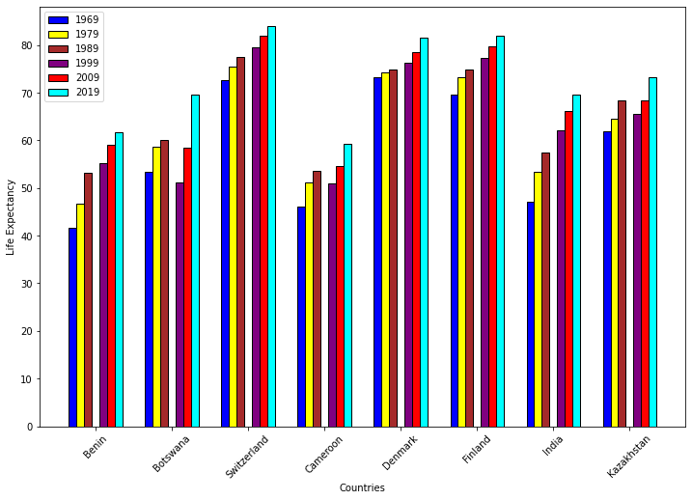

The bar graph above shows the life expectancy of different countries from the year 1969 to 2019 in 10 years increments. Switzerland has the high life expectancy, and it was in the year 2019. Denmark and Finland have the almost similar life expectancy. Least life expectancy is seen in the countries Benin and Cameroon. Life expectancy increased with the time and we can easily be able to see that in people has the least expectancy in the year 1969 whilst highest in the year 2019. Life expectancy of some countries named Botswana, India and Kazakhstan in 2019 is almost like each other.

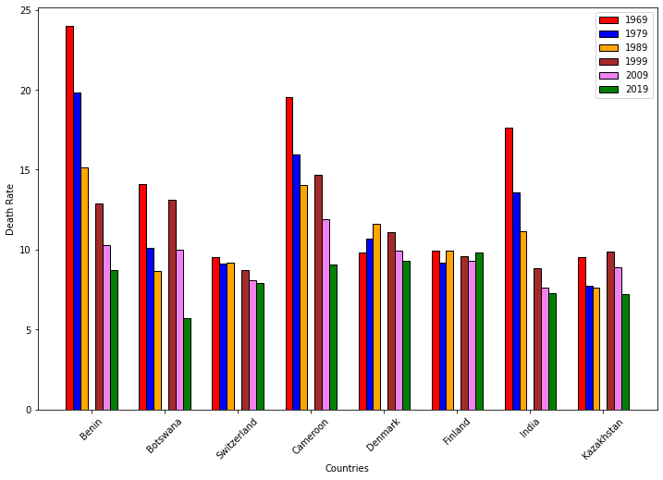

This bar graph compares the Death Rate of the 8 countries named Benin, Botswana, Switzerland, Cameroon, Denmark, Finland, India and Kazakhstan. Death rate decreased with the time. Death rate in the year 1969 was too high compare to 2019. Country named Benin has the high death rate in 1969 followed by Cameroon and India. Switzerland, Finland and Denmark have not much difference in their life expectancy between the year 1969 and 2019. After comparing these 2 graphs we can clarify that life expectancy is inversely proportional to death rate.

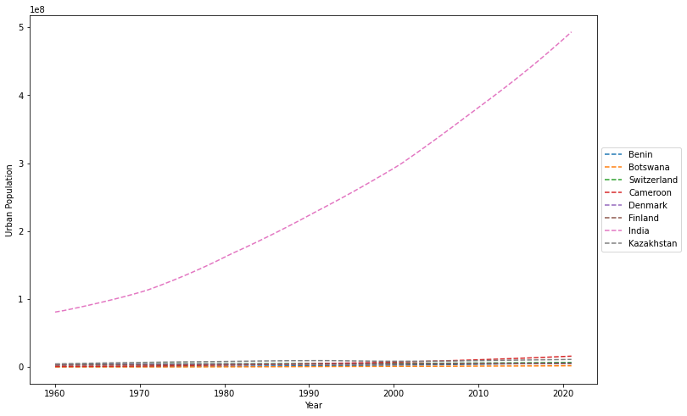

The graph illustrates the urban population from the year 1960 to 2020 of the 8 different countries. We can clearly see that the population of India increased rapidly from the year 1960 to 2020. Remaining 7 countries have almost similar urban population in all years. Cameroon has negotiable increase in the population in year 2020.

This line graph above depicts the fertility rate among 8 countries from year 1960 to 2020. We can clearly see that fertility rate of all countries except Kazakhstan decreases with time. Switzerland’s fertility rate increases from year 1970 to 1987 and suddenly start decreasing till year 2020. The country named India and Botswana shows the sudden decrease from 1960 to 2020 in fertility rate. Kazakhstan’s fertility rate decreases from year 1960 to 2000 and starts increasing from 2000 to 2020. Denmark, Switzerland and Finland have the least fertility rate among all other countries. We can clearly see that India has the high urban population, but its fertility rate is decreasing whilst Benin has the high fertility rate, but its urban population is too low. We conclude by comparing these 2 graphs that countries fertility rate doesn’t affects its urban population.